INTRODUCTION

Globally, seagrasses are one of the most important coastal ecosystems, due to the high value of their ecosystem services, such as primary production, food supply, nutrient cycling, habitat formation, coastal protection, and carbon sequestration (Costanza *et al.* 1997; Ondiviela et al., 2014; Unsworth et al., 2019; UNEP, 2020). Despite their importance, seagrasses were until recently considered the perfect example of an ecosystem that is largely undocumented and understudied (Waycott, et al. 2009).

Recently, several authors have reported the global decline in seagrass meadows at unprecedented rates, due to global climate change, overfishing, even anthropogenic activities, mostly coastal modification, and water pollution (Orth et al., 2006; Duarte et al., 2009). The Gulf of California is one of the regions where this problem occurs (López-Calderón et al., 2010, Riosmena-Rodríguez et al., 2013; López-Calderón et al., 2016).

Nowadays, we know the Gulf of California is home to four species of seagrass: *Zostera marina* L. 1753, *Halodule wrightii* Ascherson 1868, *Halophila decipiens* Ostenfeld 1902 and *Ruppia maritima* L. 1753. According to the historical distribution, the seagrasses are mainly found in the Canal del Infiernillo in Sonora and the coastal lagoons in Sinaloa, while in the Baja California Peninsula, the most representative site is Bahía Concepción (Den-Hartog, 1970; Felger & Moser, 1973; McMillan, 1983; Aguilar-Rosas & López-Ruelas, 1985; Ortega et al., 1986; Ramírez-García & Lot, 1994; Riosmena-Rodríguez & Sánchez-Lizaso, 1996, Meling-López and Ibarra-Obando, 1999; Múñiz-Salazar et al., 2005; Orduña-Rojas & Riosmena-Rodríguez, 2008; Santamaría-Gallegos *et al.* 2006; López-Calderón et al., 2010).

This review focuses on the current state of knowledge of seagrasses in the Gulf of California. Based on the collected information, we made the first full assessment of the distribution, coverage and conservation status of the ecosystem, creating a threat index and provided a baseline to contribute to the study and conservation strategies of seagrass meadows.

MATERIAL & METHODS

STUDY SITE

El Golfo de California es un mar parcialmente cerrado ubicado entre la península de Baja California y la región noroeste de México. Tiene una extensión aproximada de 1600 km de longitud y 283,000 km2,en la que se encuentran alrededor de 900 islas e islotes. Es posible distinguir cuatro regiones oceanográficas: El Alto Golfo, El Golfo Norte, Región Central y El Golfo Sur (SEMARNAP 2000)

[…]

SYSTEMATIC REVIEW PROTOCOL

Three information sources were used for the database: specific literature, indirect literature and both national and international herbariums.

For this review, the keywords “Seagrasses”, “Gulf of California”, “*Zostera marina*”, “*Ruppia maritima*”, “*Halodule wrightii*” y “*Halophila decipiens*” were searched into Scholar (accessed 07/2019-01/2021). The selected information is made up of: scientific articles, bachelor, master's and doctorate theses; floristic inventories, book chapters and technical reports from academic and governmental institutions, which address the issue of seagrass in the Gulf of California from different perspectives. Also, despite not discussing seagrasses as central theme, some texts that could provide us some reference about distribution and / or extension were chosen.

Finally, the online collections of seven herbaria were reviewed: Herbarium of the University of Arizona (ARIZ), Herbarium of the Arizona State University (ASU), Herbarium of the Autonomous University of Baja California (BCMEX), Herbarium Nacional de Mexico (MEXU), Smithsonian National Museum of Natural History (SI NMNH), Herbarium Jesús González Ortega of the Autonomous University of Sinaloa (UAS), Herbarium of the University of Sonora (UNISON-USON).

From all information collected, four essential elements for the database were extracted: species, date, location and coordinates. With these data, maps of historical distribution of seagrass in the Gulf of California were made. Finally, the periods in which there was an increase in seagrass studies were identified and these were classified based on the topic they address.

Evaluation Criteria

For the evaluation criteria, the risk assessment model of the Red List of Ecosystems proposed by the IUCN (2016) was followed, which includes two non-threat categories: Least Concern (LC) and Near Threatened (NT), three threat categories: Critically Endangered (CR), Endangered (EN) and Vulnerable (V); and a collapsed ecosystem category (CO). In addition to a category that reflects the lack of information: Insufficient data (DD) and another for ecosystems that have not been even minimally evaluated: Not evaluated (NE).

According to the Practical Guide for the Application of the IUCN Red List of Ecosystems Criteria (Rodríguez et al. 2015), to determine the risk of collapse, which is the most critical category, five criteria will be evaluated based on one or more proxies. It is important that the evaluation is made with existing data, otherwise, the ecosystem will be classified as DD (Data Deficient). The evaluation criteria includes:

* 1. Currently declining distribution
  2. Restricted distribution
  3. Degradation of the abiotic environment
  4. Altered biotic interactions
  5. Quantitative estimates of risk of ecosystem collapse

Once all the criteria have been evaluated, a final category, which summarizes all the results from the evaluation, is assigned. Based on the results and following the precautionary principle (Precautionary Principle Project 2005), the highest category obtained for any of the criteria will be considered as the general status of the ecosystem.

**Assessment variables**

To assess threat categories, we choose the following variables:

* Pollution
* Coastal modification
* Biological resources use
* Validation
* Protection level
* Marine Heatwaves

The information about the first three variables was obtained by information sheets on Ramsar Wetlands website ( https://www.ramsar.org/) and evaluation and characterization sheets by Comisión Nacional de Áreas Naturales Protegidas (). These variables were selected because all of them occurs un the study area and it is know some human activities such fisheries, aquaculture, livestock or even dredge and coastal modification, are threats highly related with loss and degradation of seagrasses ecosystems (Short et al. 2011). For each variable a score 0 to 1 was assigned, where 0 is absence, and 1 is presence of the threat.

For the validation process, the data base GC_Seagrasses2021 was used to mapping the historical distribution of seagrasses in the Gulf of California. Later, satellite images were used to validate the presence or absences of seagrasses in the historical spots, in some cases, such La Paz bay, validation was carried out with drones. It was necessary to evaluate through two main approaches because the localities varied in their extension and in the access to the field. In this case, a score 0 to1 was also assigned, however, this was based at the threat of looses. Where 0 means the current present of seagrass in the spot, a score of 0.5 means that there is not information about the spot, therefore it was classified in DD and finally, a score of 1 means the loose of a seagrass spot

To assess the protection level, a Federal Natural Protected Areas (CONANP) shapefile was used. Due several authors have reported the effect of marine protected areas on the recovery and stability of threatened ecosystems (….), to identify how many records were included within on a protected polygon the merge between the NPA shapefile and the and the information of GC_Seagrasses2021 shapefile was made.

For Marine Heatwaves, we retrieved Reynolds optimally interpolated sea surface temperature (OISST) data to calculate marine heatwaves events. Marine heatwaves are recognized threats to marine life with the potential to cause significant damage to natural communities (Beas‐Luna et al., 2020; Benedetti-Cecchi, 2021; Brown et al., 2020; Filbee-Dexter et al., 2020; Laufkötter et al., 2020; Suryan et al., 2021), are related to human induced climate change (Laufkötter et al., 2020), and can exacerbate other climate change effects (Cheung and Frölicher, 2020). We used the R package heatwaveR to identify heatwaves and calculate temporal trends from OISST data. The download and extraction process, as well as the analysis is fully reproducible using the R code provided at: GITUHUB LINK. The code was written in the R studio IDE (v.1.4.1103) working on R v.4.0.3.

Results and discussion

Summary of seagrass distribution and abundance in

* DISTRIBUTION MAP: PRESENCE/ABSENCE. (1)

We found that there are seagrasses at 13 of the 28 historically identified sites. In the Gulf of California, the most widely distributed seagrass is Ruppia maritima, which is found almost everywhere, and its range of distribution goes from Ciénega de Santa Clara, in the Upper Gulf of California to the Huizache-Caimanero Lagunar Complex. , In Sinaloa

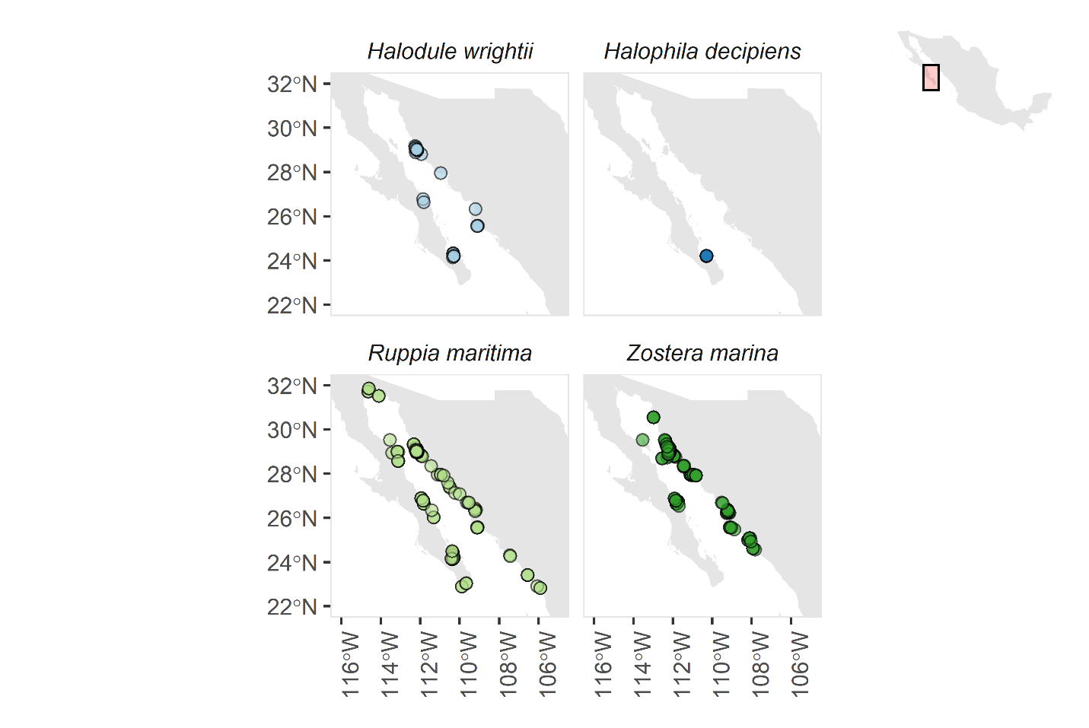

* SUMMARY (TABLE: CURRENT DISTRIBUTION: SITE/DATE/SPECIE/LAT/LONG(3).
* RESEARCH PER DECADE (PLOT) (2)

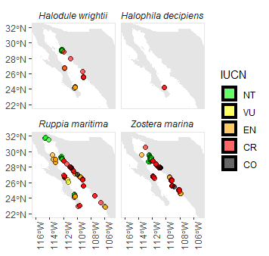

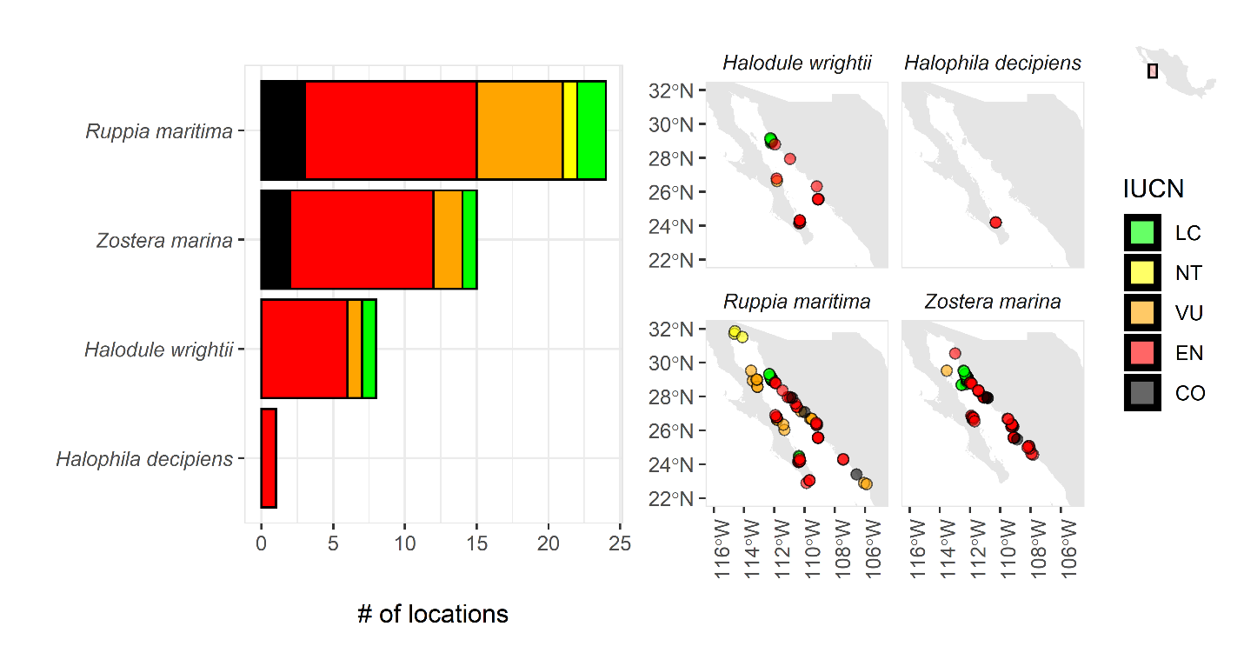

DISCUSSION

* HISTORICAL DISTRIBUTION VS CURRENT DISTRIBUTION SITE (1)
* WHAT WE KNOW TODAY?(2&3)BY
* TAXONOMY DISCREPANCY
* WHY SEAGRASSES ARE IN THE CURRENT SITES?(1&3)
* BIOTIC & ABIOTIC FACTORS(1&3)
* INVASIVE?/TROPICALIZATION (1&3)
* CONSERVATION STATUS (4)

*** FUTURE CHALLENGE

* NECESSARY ACTIONS AND PROPOSALS

References

Aguilar-Rosas R, López-Ruelas J (1985) *Halodule wrightii* Aschers (Potamogetonales: Cymodoceae) in Topolobampo Bay, Sinaloa, Mexico. Cienc Mar 11:87–91

Beas‐Luna, R., Micheli, F., Woodson, C.B., Carr, M., Malone, D., Torre, J., Boch, C., Caselle, J.E., Edwards, M., Freiwald, J., Hamilton, S.L., Hernandez, A., Konar, B., Kroeker, K.J., Lorda, J., Montaño‐Moctezuma, G., Torres‐Moye, G., 2020. Geographic variation in responses of kelp forest communities of the California Current to recent climatic changes. Global Change Biol 26, 6457–6473. https://doi.org/10.1111/gcb.15273

Benedetti-Cecchi, L., 2021. Complex networks of marine heatwaves reveal abrupt transitions in the global ocean. Sci Rep-uk 11, 1739. https://doi.org/10.1038/s41598-021-81369-3

Brown, C.J., Mellin, C., Edgar, G.J., Campbell, M.D., Stuart‐Smith, R.D., 2020. Direct and indirect effects of heatwaves on a coral reef fishery. Global Change Biol. https://doi.org/10.1111/gcb.15472

Cheung, W.W.L., Frölicher, T.L., 2020. Marine heatwaves exacerbate climate change impacts for fisheries in the northeast Pacific. Sci Rep-uk 10, 6678. <https://doi.org/10.1038/s41598-020-63650-z>

Costanza R, et al. (1997) The value of the world’s ecosystem services and natural capital. Nature 387:253–260.

Den-Hartog C (1970) The seagrasses of the world. North Holland Publishing, Amsterdam

Duarte, C.M., Culbertson, J., Dennison, W.C., Fulweiler, R.W., Hughes, T., Kinney, E.L., Marbá, N., Nixon, S., Peacock, E.E., Smith, S., Valiela, I., 2009. Global Loss of Coastal Habitats: Rates, Causes and Consequences. Carlos Duarte Fundacion BBVA, Bilbao, Spain, p. 175

Felger R, Moser MB (1973) Eelgrass (Zostera marina L.) in the Gulf of California: discovery of its nutritional value by the Seri Indians. Science 181:355–356

Filbee-Dexter, K., Wernberg, T., Grace, S.P., Thormar, J., Fredriksen, S., Narvaez, C.N., Feehan, C.J., Norderhaug, K.M., 2020. Marine heatwaves and the collapse of marginal North Atlantic kelp forests. Sci Rep-uk 10, 13388. <https://doi.org/10.1038/s41598-020-70273-x>

IUCN-CEM 2016. The IUCN Red List of Ecosystems. Version 2016-1. [http://iucnrle.org](https://iucnrle.org/), consultado el 30 Octubre 2020.

Laufkötter, C., Zscheischler, J., Frölicher, T.L., 2020. High-impact marine heatwaves attributable to human-induced global warming. Sci New York N Y 369, 1621–1625. <https://doi.org/10.1126/science.aba0690>

López Calderón J., R. Riosmena Rodríguez, J.M. Rodríguez Baron, J. Carrión-Cortez, J. Torre, J. Meling López, G. Hinojosa Arango, G. Hernández Carmona, J. García Hernández. 2010. “Outstanding Appearance of Ruppia maritima along Baja California Sur, Mexico and Its Influence in Trophic Networks”, en Marine Biodiversity doi 10.1007/ s12526-010-0050-3.

López-Calderón, J. M., Riosmena-Rodríguez, R., Torre, J., Meling, A., & Basurto, X. (2016). Zostera marina meadows from the Gulf of California: conservation status. *Biodiversity and conservation*, *25*(2), 261-273.

McMillan C (1983) Seed germination for an annual form of Zostera marina from the Sea of Cortez, Mexico. Aquat Bot 16:105–110

Meling-López AE, Ibarra-Obando SE (1999) Annual life cycles of two Zostera marina L. populations in the Gulf of California: contrasts in seasonality and reproductive effort. Aquat Bot 65:59–69

Muñiz-Salazar R, Talbot SL, Sage GK, Ward DH, Cabello-Pasini A (2005) Population genetic structure of annual and perennial populations of Zostera marina L. along the Pacific coast of Baja California and the Gulf of California. Mol Ecol 14:711–722

Ondiviela, B., Losada, I.J., Lara, J.L., Maza, M., Galván, C., Bouma, T.J. et al. (2014). The role of seagrass in coastal protection in a changing climate. Coastal Engineering 87, 158–168. https://doi. org/10.1016/j.coastaleng.2013.11.005

Orduña-Rojas J, Riosmena-Rodríguez R (2008) Inventario de la macrofauna marina de interés económico de las islas del norte de Sinaloa, México (Ed.) Sinaloa PFC-. CIDIR Unidad Sinaloa, Guasave, pp 1–36

Ortega MM, Ruiz-Cárdenas J, Oliva-Martínez MG (1986) La vegetación sumergida en la Laguna Agiabampo, Sonora-Sinaloa. An Inst Biol Univ Nal Autón México Ser Bot 57:59–108

Orth RJ, Carruthers TJ, Dennison WC, Duarte CM, Fourqurean JW, Heck KL (2006) A global crisis for seagrass ecosystems. Bioscience 56(12):987–996

Precautionary Principle Project. 2005 Guidelines for applying the precautionary principle to biodiversity conservation and natural resource management, 7 p. Cambridge, UK: The Precautionary Principle Project—a joint initiative of Fauna & Flora International, IUCNThe World Conservation Union, ResourceAfrica and TRAFFIC.

Ramírez-García P, Lot A (1994) La distribución del manglar y de los ‘‘pastos marinos’’ en el Golfo de California, Me´xico. An Inst Biol Univ Nal Autón. México Ser Bot 65:63–72

Riosmena-Rodríguez R, Sánchez-Lizaso JL (1996) El límite sur de distribución de Zostera marina L. y Phyllospadix torreyi Watson para el noroeste mexicano. Oceánides 11:45–48

Riosmena-Rodríguez R, Múñiz-Salazar R, López-Calderón J, Torre-Cosio J, Meling A, Talbo SL (2013) Conservation status of Zostera marina populations at Mexican Pacific. In: Daniels JA (ed) Advances in environmental research, vol 27. Nova Science Publishers, New York, pp 35–63

Rodríguez, J. P., D.A. Keith, K.M. Rodríguez-Clark, N. J. Murray, E. Nicholson, T.J. Regan, & T. M. Brooks. 2015. Una guía práctica para la aplicación de los criterios de la lista roja de ecosistemas de UICN.Phil. Trans.R. Soc. B 370: 20140003

Santamaría-Gallegos, N. A., Riosmena-Rodríguez, R., & Sánchez-Lizaso, J. L. (2006). Occurrence and seasonality of Halophila decipiens Ostenfeld in the Gulf of California. *Aquatic botany*, *84*(4), 363-366.

Suryan, R.M., Arimitsu, M.L., Coletti, H.A., Hopcroft, R.R., Lindeberg, M.R., Barbeaux, S.J., Batten, S.D., Burt, W.J., Bishop, M.A., Bodkin, J.L., Brenner, R., Campbell, R.W., Cushing, D.A., Danielson, S.L., Dorn, M.W., Drummond, B., Esler, D., Gelatt, T., Hanselman, D.H., Hatch, S.A., Haught, S., Holderied, K., Iken, K., Irons, D.B., Kettle, A.B., Kimmel, D.G., Konar, B., Kuletz, K.J., Laurel, B.J., Maniscalco, J.M., Matkin, C., McKinstry, C.A.E., Monson, D.H., Moran, J.R., Olsen, D., Palsson, W.A., Pegau, W.S., Piatt, J.F., Rogers, L.A., Rojek, N.A., Schaefer, A., Spies, I.B., Straley, J.M., Strom, S.L., Sweeney, K.L., Szymkowiak, M., Weitzman, B.P., Yasumiishi, E.M., Zador, S.G., 2021. Ecosystem response persists after a prolonged marine heatwave. Sci Rep-uk 11, 6235. <https://doi.org/10.1038/s41598-021-83818-5>

United Nations Environment Programme (2020). Out of the blue: The value of seagrasses to the environment and to people. UNEP, Nairobi.

Unsworth, R.K.F, McKenzie, L.J., Collier, C.J., Cullen-Unsworth, L.C., Duarte, C.M., Eklöf, J.S. et al. (2019). Global challenges for seagrass conservation. Ambio 48(8), 801–815. https://doi.org/10.1007/ s13280-018-1115-y

Waycott M, Duarte CM, Carruthers TJB, Orth RJ, Dennison WC, Olyarnik S (2009) Accelerating loss of seagrasses across the globe threatens coastal ecosystems. Proc Natl Acad Sci 106(30):12377–12381